The ham-Hams are playing out football, and the girls (behalve but NOT Sandy and bijou they playing with them) says come on ham-hams!.
Nobody look at the Mountains by the clubhouse, where a little hamster was.
She says come on ham-hams! As they other.
But then it started to rain.
The ham-hams run all inside but penelope wasn’t fast enough.
Penelope she is NOT fast enough says pashmina.
Then er was a Cat and it started to run after penelope.
Ookwee ookwee! Cryd penelope.
I save you!
Everyone look up and they saw that girl in a superhero costum!
Stupid Cat, nobody mess with superhero hammagirl!
Superhero hammagirl? Boss look crazy, and howdy laught hard.
Don’t laugh me out says she and she gets boss nok out with her sword.
Sorry says howdy ,he don’t wants be nok out as boss.
Then she changed back to a normal ham.
Come in says bijou, you don’t want to stay in the rain.
Okay says she.
Who are you? asked boss.
I am sandyhamutaro, i can change in superhero hammagirl!
Sandyhamutaro? What!that can’t be! Says Sandy.
It can’t be? What’s going on here? Says Hamtaro.
She is my escaped little sister says Sandy.
What? Sandy are you it? cryd sandyhamutaro
Yes little sister i am it says Sandy.
You are one of the ham-hams now sandyhamutaro says hamtaro with a smile.
Thank-Q says she.
Tomorrow we have more fun says hamtaro.
Goodbye.
The End!

Here are some pictures:
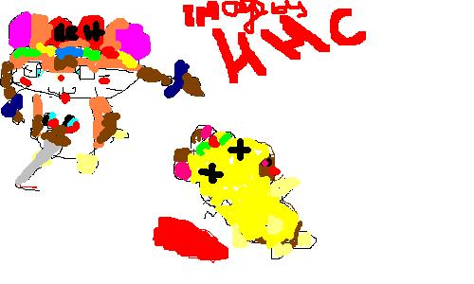
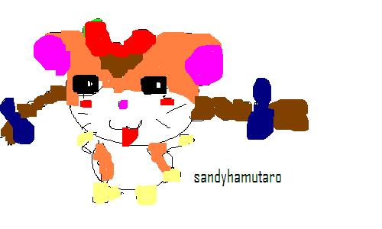made by sandyhamutaro on hhc

